37.64: Setting  in Eq. (37.21), the first equation becomes 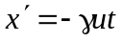 and the last, upon multiplication by 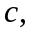 becomes 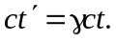Squaring and subtracting gives
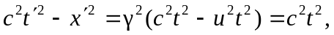
or